Distribution Worklist

Select the Criteria. These are set up in the layout preference for selection.

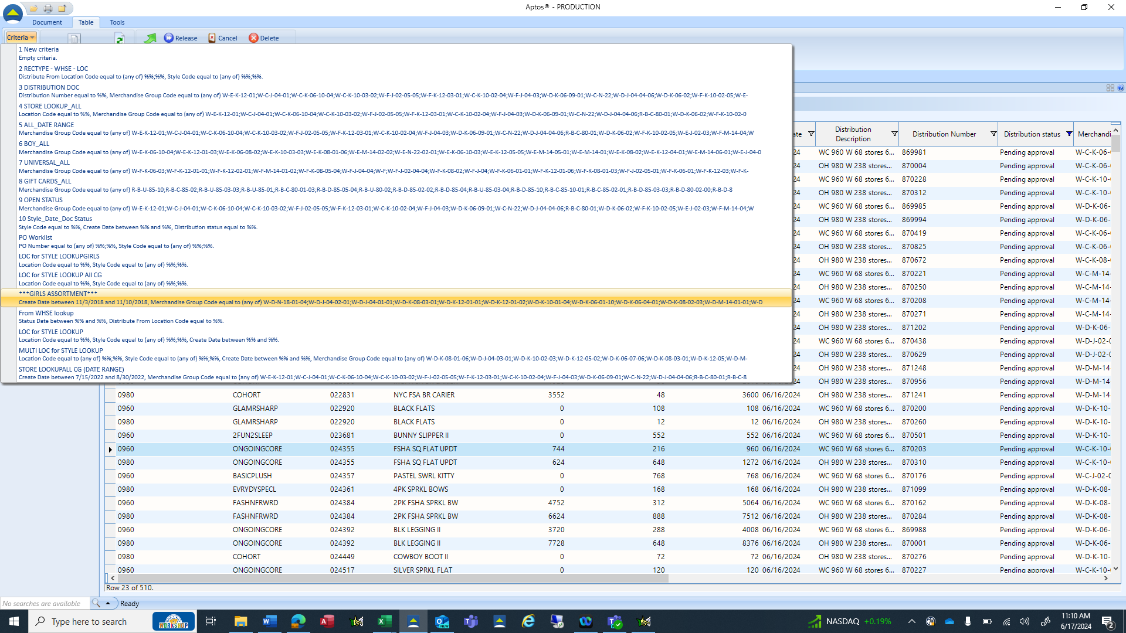

Distribution worklist includes all pending documents for all warehouses. Column layout includes warehouse code (Distribution From Location Code), key story (Style Custom Prop Value), Style Code, remaining inventory (Line Reserve Quantity), Total Distributed Quantity, and Total Available Quantity.



Open the document by clicking on the line in the distribution worklist.

View the store detail by clicking on the SKU Location Quantities from the Navigation Bar menu on the left.



Click in the DQ (distributed quantity) cell to view the individual store’s effective inventory, Minimum/Maximum, and Presentation Stock quantity.



When the document has been reviewed click the Actions drop down and select Release. If the document is determined to be unnecessary delete is another available action from this drop-down menu.

Released status.

